United Arab Bank maintains social responsibility focus while growing exponentially

United Arab Bank’s (UAB) business objectives go hand in hand with the community service as UAB believes in giving back to the community.
Over the years, the Bank has developed a long standing relationship with Al Thiqah Club for Handicapped and has been supporting and recruiting citizens with special needs for many years. UAB is the exclusive sponsor of all the Programme Training sessions, with the sole objective of inducting the special-needs citizens into the local community by developing their interpersonal and professional skills, and by offering employment opportunities within the Bank.
UAB also collaborates with Al Thiqah in several other areas, sponsoring key events and activities organized by the Club. Such activities reinforce UAB’s commitment to contribute to the development of the local community and to make an appreciable difference to its citizens.
At UAB, recruitment and development of the UAE Nationals is recognized as a social responsibility, one which is essential to a competitive advantage in the markets UAB operates in. With this view, UAB’s Emiratization Programme, Al Tamayouz, continues to build from strength to strength with the percentage of UAE National employees growing from 41% to 43% in 2012. This programme empowers qualified UAE Nationals with career growth opportunities through an individualized development plan encompassing internship opportunities, student sponsorship and full-time career advancement.
UAB strives to attract, retain, and continuously develop the skills of UAE Nationals. At UAB emiratization strategy goes beyond recruiting UAE Nationals. UAB is committed to ensuring sustainability of the UAE economy by developing tomorrow’s leaders through enhancing the skills of UAE Nationals.
In addition to its regular CSR activities, in 2012, UAB joined hands with Awqaf & Minors' Affairs Foundation to disburse meals to over 3,000 deserving people during the holy month of Ramadan.

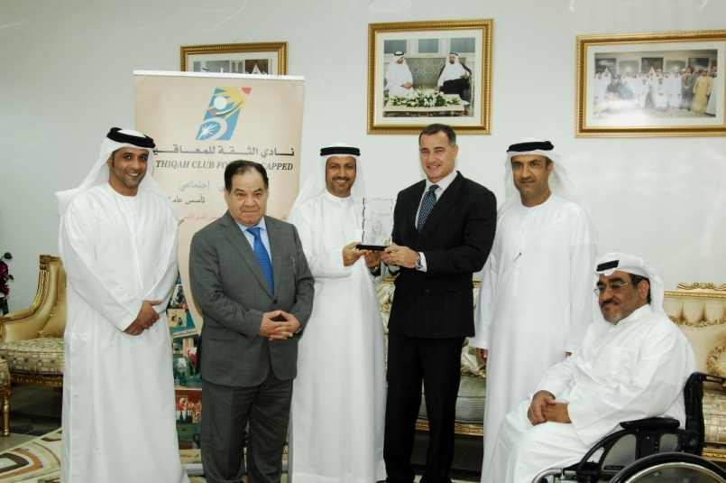
UAB’s CEO, Mr Paul Trowbridge and other senior executives being honoured by the ‘Al Thiqah Club for Handicapped’, for UAB’s continuous support to the club and its activities.

---------

